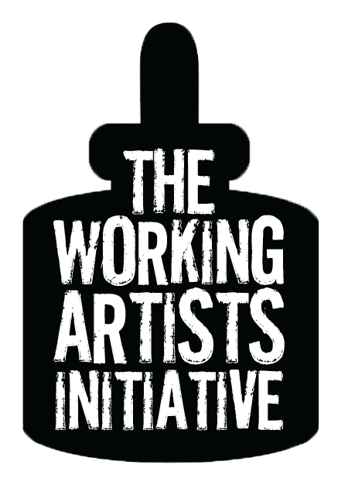
Project Worksheet

NAME:

What project will you complete during WAI?

Vision
Describe the form of your work you will be doing (paintings, book, film, songs, etc).

Describe the topic and themes.

Describe the scope (number of pieces, pages, songs, length, etc).

Completion
What is the definition of “complete”? Do you want to have your paintings framed and gallery-ready, or simply finish painting the canvases? Are you writing a first draft, or a finished manuscript? Are you shooting a film, or shooting and editing? What will you have produced at the end of this program?

Project Worksheet

Increments
There are 12 weeks in WAI. How much work do you need to do each week in order to complete your project? How many pages or songs do you need to write, jewelry pieces do you need to craft, paintings do you need to finish? Be realistic: account for weeks when you simply won’t be able to get much done, like around the holidays, or when you have pressing family or work obligations. Be conservative: allow yourself a few weeks of flex time, so that you can complete your project even if something unexpected happens (or complete even more than you expected if things go smoothly). Consider if you want to leave time at the end to tie up loose ends, polish, and publish your work. Set target dates for beginning and completing each phase.

Commitment
We make two commitments to the group each week: how much time we plan to spend, and what we plan to accomplish. How much time do you plan to devote to your project each week (should be at least 4 hours)?

What will you accomplish in that time?

When will you spend this time? What part of your life can you consistently devote to your art? A few mornings or evenings a week? Lunch breaks? Weekend mornings or afternoons? It doesn’t have to be the same time each week, but reserving a consistent time for making work is a powerful habit. Where will you carve out a consistent time in your life for your art?

(Come to the 1st meeting with your calendar in hand!)

