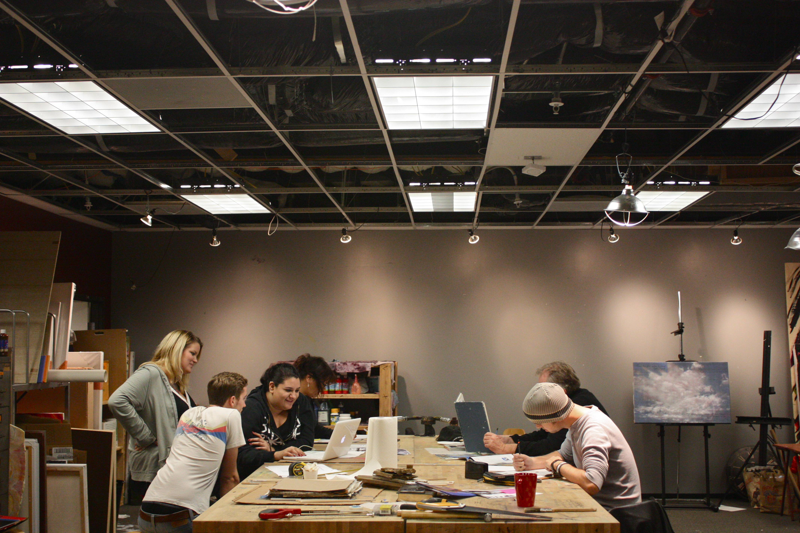

SERVE TEAMS

Artisan Team
Community Art Team
Exhibits Team
Host Team
Story Team
Support Team
* Leadership Team *

TEAM DAY | 1ST SATURDAYS
Discover Teams, Share Ideas, Initiate projects
10 AM TEAMS : Exhibits / Host / Community Art
1 PM TEAMS : Artisan / Story / Support

SERVE IN YOUR SHAPE
These volunteer positions are meant to empower you to use your SHAPE (Spiritual gifts, Heart, Abilities, Personality, Experiences) to serve and influence your community.

* To be on a SERVE TEAM fill out an Application
All skill levels have a place on these teams.

COMMUNITY ART TEAM

Create art pieces for direct engagement or participation.

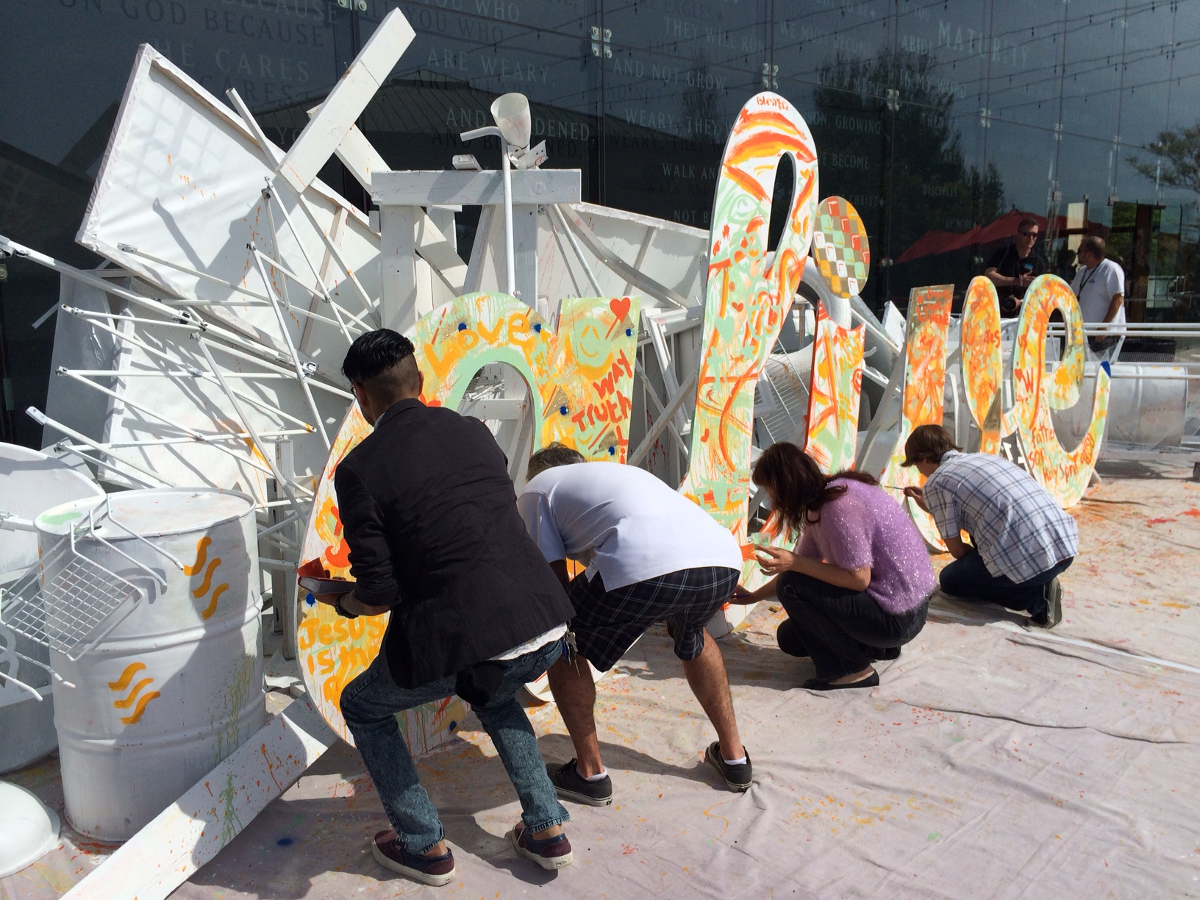

The Community Art team is all about creating art that directly engages people. Most of these projects are large scale and require a team of artists working together. These interactive or and socially engaged projects make space for people to become participants and engage in conversation. Some projects are for a church campus while others are meant to engage people in the margins of society.

Abilities (any of the following)

- Ideation
- Constructing
- Assembling
- Crafting/Designing
- Purchasing and testing materials
- Project Installation
- Engaging people in conversation

Personality
- People-Oriented
- Team-Player
- Hard Working
- Intuitive
Frequency: Quarterly large scale projects

*Related: ART FOR HEALING. Contact Melissa Bayes
EXHIBITS TEAM

Select and install local artwork and design spaces.

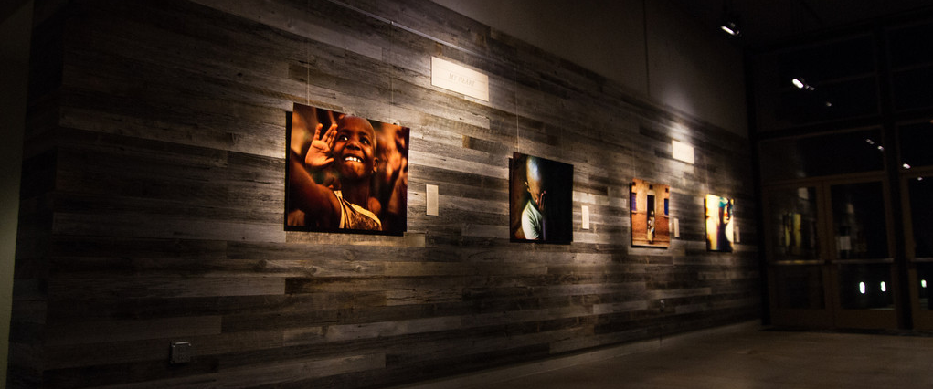

The Exhibits team transforms the spaces on our campuses to make the church into a place that reflects God’s creative soul through exhibits and public art. Together, we find great artists, decide on show themes, prepare show elements, and install these works of art.

The Exhibits team also looks at spaces around campus, indoors and outdoors, that need attention and design. You may help us come up with design solutions for a space or find artists who can paint a mural or create a sculpture to bring a space to become a better reflection of the creative God we serve

Abilities: (we will train you!)

- Designing indoor/outdoor spaces
- Installing artwork
- Technical skills with measurement and basic tools.
- Creating labels and plaques
- Cataloguing of artwork

Personality:
- Attention to detail
- Decisive
- Activator
- Team collaborator
Frequency: Monthly Upkeep to Quarterly Gallery Exhibits
HOST TEAM

Prepare the space and welcome people coming to the studio.

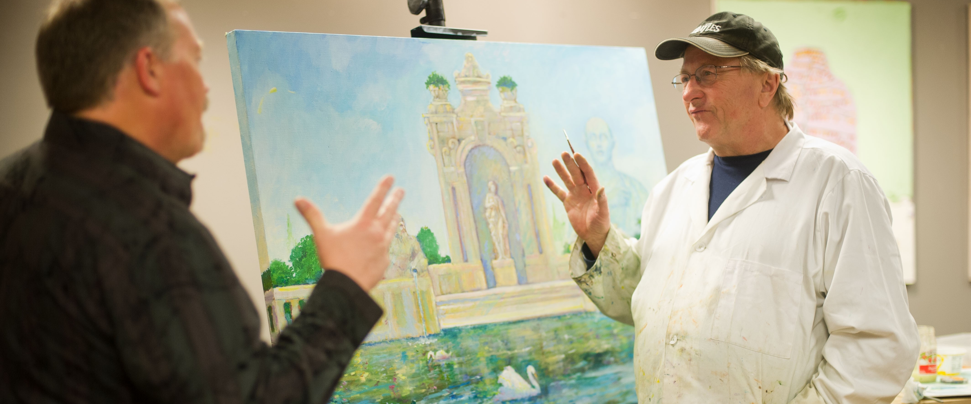

The Host team is made up of studio hosts who help run our creative events. Studio Hosts prepare the studio, show love and hospitality to artists coming into the studio, and keep the space running during the event. The Host team helps keep our creative spaces at top notch while making those who come through the doors feel at home.

Abilities

- Greeting and meeting people
- Organizing/Cleaning spaces
- Prompt
- Hospitality
- Responsible
- Self-Sufficient

Personality:

- Relational
- Extroverted
- Forward
- Aware
- Hospitable
- Organizer

Frequency: 1-2 times/month

ARTISAN TEAM

Offer your specific talents as a skilled artist.

The Artisans team is made up of qualified artists that wish to offer their specific skills for various projects. We will ask for your involvement in projects you would excel at knowing your specific giftedness in the arts. This could be anything from sculpture, construction, mural painting, kids illustrations, graphic design, typography, or another art form of expertise.

Abilities:

- Skilled in the arts
- High sense of craftsmanship
- Taking project ideas
Personality:

- Flexible
- Creative
- Responsive
- Heart for service

Frequency: Not specified

* You will be asked to submit a portfolio of your work.
STORIES TEAM

Capture and share creative culture through various media.

The Stories Team seeks to capture and share the incredible stories and visuals that are happening every week in the creative culture of the church. People involved on this team are writers, social media enthusiasts, photographers, and videographers, all working together to create and share compelling stories among the art and faith community.

Abilities (any of the following)

- Finding and writing stories
- Journalistic writing
- Interviewing
- Social media strategy
- Instagram, Facebook, Etc
- Digital design
- Wordpress/web
- Photography
- Video

Personality:

- Attentive
- Self starter
- Heart for community
- Collaborator
- Listener

Frequency: Monthly team gathering.
Weekly social media activity.
Attend events to capture in writing and images.
SUPPORT TEAM

Create and maintain important structures for our ministry.

The Support team is made up of people who excel in organization and administrative skills that our creative community needs to stay alive and well. This team leads various projects such as organizing volunteers and schedules, creating and maintaining systems that keep the physical studio organized, and managing digital files and image systems.

Abilities

- Digital Organization
- Data Entry
- Volunteer Organization
- Scheduling
- Space organization
- Administrative tasks

Personality

- Very organized
- Task-oriented
- Enjoys systems
- Self-sufficient
Frequency: weekly - monthly

* LEADERSHIP TEAM

Influence the shape our community. You must have a heart for this community and experience in the arts.

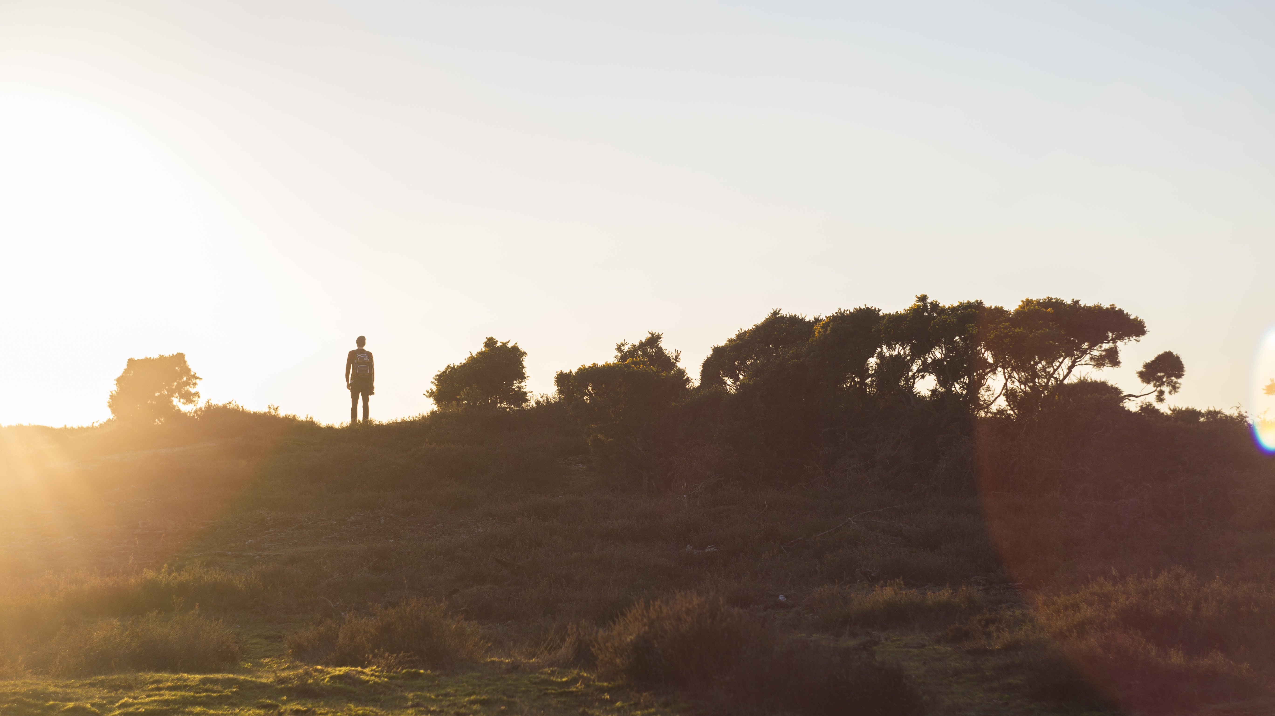

Our Leadership team is a small group amongst our community that is strong in their walk with God, their skill in the arts, and has a big heart for our community. Roles include leading a Team in some capacity, ministry development, or mentoring and teaching artists in our community who are looking to grow in their artistic skills and faith journey.

Abilities:

- Teaching
- Wisdom
- Good communicator
- Great skill in your art form
- Maturity in walk with Christ
- Activator

Personality:

- Responsible
- Dedicated/Consistent
- People-Oriented
- Patient
- Loving
- Generous
- Confident

Frequency: Weekly

If you’re new to Saddleback Visual Arts, and want to be in leadership, start by joining and serving with us.
If you’ve been with us for some time and ready for something like this now, talk to our director.

